### The 8x8 Shelter 2.0 design

**INTRO:**

The Shelter 2.0 design is a digitally-fabricated structure originally designed to be transitional housing, needed in the time between initial emergency response with tents and temporary housing, and permanent reconstruction/relocation. It has a raised floor, doors for security, open space in walls for insulation, and is built from materials that give it a lifespan much longer than many other options. It was also created to be fabricated efficiently in a CNC machine and to be assembled by unskilled labor with minimal tools. More information can be found at the project at [www.shelter20.com](http://www.google.com/url?q=http%3A%2F%2Fwww.shelter20.com&sa=D&sntz=1&usg=AFQjCNHGmt5wvycYHUu8Pm-v3tZeb_JMYw)

##### MATERIALS AND HARDWARE:

For the 3/4" material we like [Advantech](http://www.google.com/url?q=http%3A%2F%2Fwww.advantechperforms.com%2F&sa=D&sntz=1&usg=AFQjCNEZREUpAbR5uLDed6usYU2lsofsDQ) from Huber...it's stable, stays flat for easy CNC cutting, is environmentally sound, and is strong and weather resistant. The ½” panels are cut out of plywood and we try to use Radiata Pine plywood from Chile whenever we can. The two bradns we like in particular are AraucoPly and Selex for their strength and consistency

We’ve experimented with OSB and REALLY wanted it to work because it's pretty cheap, but it just doesn't have the strength or stability needed for long-term use. Your mileage may vary.

Here are the required materials for one 8x8 Structure

**Basic Structure:**

|  |  |  |
| --- | --- | --- |
| ¾” Advantech:or Plywood | Floors and sleepers | 3 sheets |
| ½” Plywood: | Ribs, endwalls, interior walls | 12 sheets |
| 1.5” x 1/4” hex bolts, nuts. washers | Rib and endwall slice plates | 82 |
| 1.5” x 1/4” hex bolts, nuts. washers | Trim for optional door (per door) | 12 |
| 1.5” x 1/4” hex bolts, nuts. washers | Optional window (per window) | 12 |
| 2” x 1/4” hex bolts, nuts. washers | Seam splice in solid endwall | 22 |
| 3” x1/4” hex bolts, nuts. washers | Sleepers | 8 |
| 2” drywall screws | Purlin and endwall attachment | ~200 |
| 7/8” drywall screws | Door trim (per door) | ~14 |

**Roof covering options:**

|  |  |  |  |
| --- | --- | --- | --- |
| 8’ x 20’ tarp | Temporary roofing | 1 |  |
| 2’ x 8’ corrugated roofing panels | Metal or plastic, your choice. If metal is chosen be sure to cover sharp edges. | 7 panels |  |
| 4’x8’x¼” plywood or plastic panel | Exterior sidewall for corrugated roof option | 2 |  |
| Screws for roofing and exterior panel | Gasketed screws for the corrugated and short drywall screws to attach the sidewall panels to the purlins | A bunch! |  |

**Optional Ceiling:**

|  |  |
| --- | --- |
| ⅛” coroplast | 4 sheets |
| small “gutter screws” to match panels | ~32 |

**Optional Door and windows:**

|  |  |
| --- | --- |
| ⅛” acrylic | 28”x20” per window |
| clear silicone caulk | 1 tube for windows and trim |
| 3” hinges with ⅝” rounded corners | 2 pairs |
| latches and locks | misc to suit location and application |

##### FILES:

The files for the 8x8 Shelter and other variations can be found on GitHub at

Included in the repository are files in several formats.

* Our preferred format is the VCarvePro ***.crv*** format. It’s the software that we use to design and fabricate all the Shelter 2.0 variations, enabling us to supply toolpath information unavailable in other CAD formats.
* We also supply CAD drawings in dxf formats, for those needing them
* Sketchup models are also included in the repository. They should be considered informational and only used to illustrate assembly information.

**Why the files are the way they are:**

I don’t in any way claim to be an expert at CNC techniques and methods, but I have cut a lot of things out of a lot of sheets of plywood over the years and have developed a system that works well for me. It may not be the most efficient way to work… there are lots of resources that are focused on production and will help you become hyper-efficient. The main benefit is that it limits the things you have to think about, and works pretty well in just about every occasion.

We’ve toolpathed these Shelter files to cut fairly conservatively, both to make sure that people with CNC tools of varying capabilities can use them and to hopefully make it easier for anyone to have success when cutting them. You are free to make as many changes you would like, but I feel like these are a good starting point

**Bits:**

I would rather not have to think about what kind of bit to use, or to have to change bits within a file if I can avoid it… but I don’t want to have to hang around the tool waiting to change the bit. So when I’m working on a project I try to pick one bit that will do everything I need it to do, and to use the largest size of that type of bit that will cut all the features in that project. All these file are toolpathed to be cut with a ¼” bit, and my go-to bit is a 2-flute straight bit. It leaves a reasonable edge and face quality, and can make shallow cuts that would be a problem with an up-cut or combination bit.

There are lots of other options though. An upspiral bit cuts cleanly, but tends to chip the top face veneer and lift your parts, even with vacuum holddown. A downspiral solves the chipping issue on the top face, and will also help hold parts down because of its geometry, but can also cause the clips to pack in the kerf, causing friction and heat which is the death of bits and potentially a fire hazard. Combination bits solve some of these problems, but the upspiral section at the tip still causes problems with shallow pockets and you really have to cut at full depth all the time to get much utility out of them.

You can certainly also change bits depending on the feature, such as using an 1/8” bit to drill for the screw holes instead of having to hand drill afterwards, or a v-bit to mark the screw hole locations with a countersink. Whatever makes you happy.

**HoldDown and Cutting Strategy:**

I have a simple Vacuum holddown system that I can’t imagine doing without one. If you’re cutting features that are depth critical like 3d carvings or parts that have to precisely interlock, holding the material firmly to the table is critical. If however you cutting shapes out of sheets, holding DOWN is only a part of what it does for you. I feel like its most important job is to hold the parts AND THE REST OF THE SHEET in place. If the material moves a little in the Z-axis you might be alright, but if it moves in X or Y you are in trouble. At the minimum you will lose the part, but sometimes ruin the whole sheet of material and/or break your bit. Not the end of the world, but a pain none the less. That doesn’t mean that you can’t cut Shelter 2.0 parts if you don’t have a vacuum holddown system, though. There are some toolpathing strategies that can help you cut Shelter 2.0 parts, with or without a vacuum system

* I generally spend a little extra time picking the order of cut for my parts, and where the start point is for the cut. The goal is to have the parts connected to the sheet for as long as possible before finally cutting them free. Imagine slicing a loaf of bread…you want to hold the loaf at one end and start slicing at the other. As you slice, everything is firmly held until the last minute. So even with a vacuum holddown I try to put clamps at the far corners of the sheets whenever I can. This helps keep the waste part of the sheet from “ooching” around as parts are cut out…those clamps are the “hand” that holds the loaf of bread!

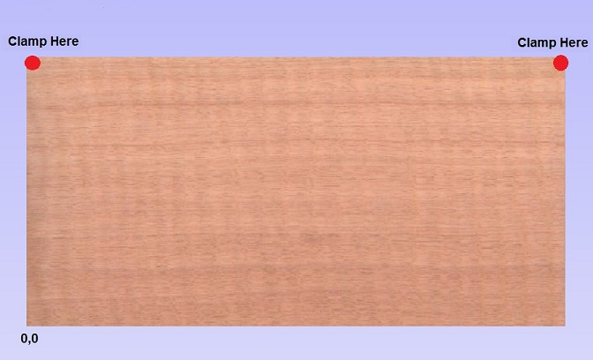

Figure 1 Clamp at corners if possible

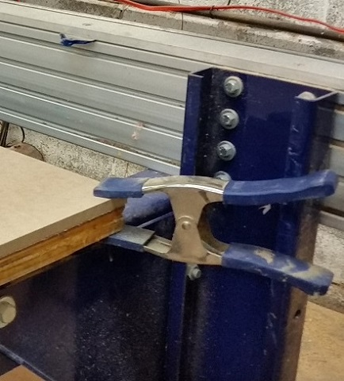

Figure 2 Clamp on corner

* I try to cut small parts first when the holddown is the best. More surface area makes larger parts easier to hold, so do them last.
* Tabs are helpful but can be a pain to remove. I generally only use them with smaller parts, and try to use one tab at the start point (in red circle below, which can be set in NODE EDIT mode). My exception to the one-tab-per-part rule is in long thin parts, like the door trim pieces. I tab the heck out of them because they will want to chatter, leaving a rough edge and probably breaking a bit

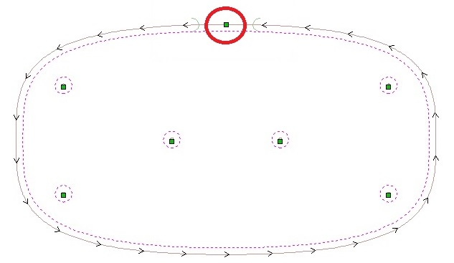

Figure 3 Single tab at start point

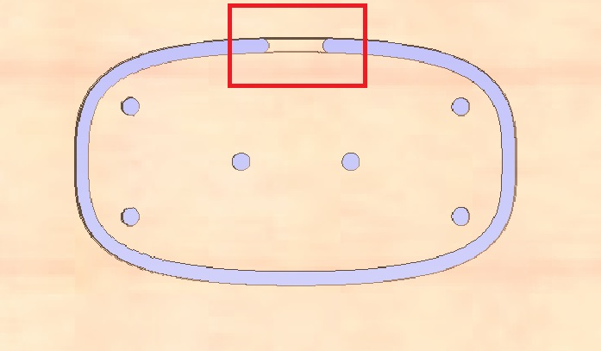

Figure 4 Preview with tab

* If you can place the tab so that it’s in a section of grain that’s parallel to the tab, it will be easier to remove. When laying out the wedges in the Shelter files, the wedges are oriented and the tabs placed so that they will be hidden in the final assembly. You won’t have to clean the tabs up after the parts are cut, but can just break them out of the sheet and use them just the way they are.

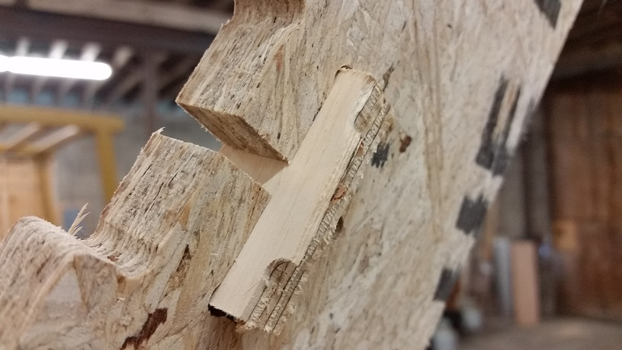

Figure 5 Place tab in area that won't be seen

**Ramping:**

I ramp into every part that I cut…it makes bits last longer and leaves a better edge. More importantly, since it’s cutting a thinner and thinner bit of material as it gets to the end of the final pass, the cutting force is reduced and the part will stay connected until cutting is finished. For most parts I use a Smooth ramp, varying between 5-8” long depending on how aggressively I’m cutting. With small parts like the wedges and the rib splice plates,however I use a Spiral ramp, which along with a tab at the start/end point gives better control of the cut and the part

**Toolpathing:**

The toolpaths are organized based on the way I would cut them. There are two “types” of toolpaths…those that start with “prelim” and those that start with a number.

The ones that start with “prelim” are eventually combined into a Merged Toolpath. Their names tell you what order that are to be cut in the merged file, and what toolpath they are merged into. For example in one sheet, toolpaths “***prelim3a-screw location markers”*** and “***prelim3b-cutout wall”*** are merged into toolpath “***3-cutout endwall”*** . Toolpaths that start with a number are meant be cut in that order. You would cut toolpath “***1-cut wedges”***, then “***2-optional window”***, and finally the merged file, “***3-cutout endwall***”,

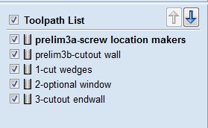

Figure 6 Toolpath list

**Layers:**

We’ve tried to use descriptive layer names to describe the entities contained in those entities. Entities in the “screwhole location marker” layer are meant to cut shallow dimples that indicate where to eventually drill pilot holes for screws. Wedges are on their own layers because of the way they are cut, and occasionally the holes in parts are on their own layers if they are to be cut using a different strategy than the other parts, such as when using a spiral plunge.

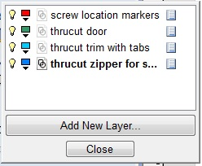

Figure 7 Layers are your friend

**Speeds:**

We’ve toolpathed these files to cut at 4”/sec and 11,000 rpm spindle speed, and to cut ½” plywood in 2 passes and ¾” plywood in 3. When I cut these parts myself in my shop though I tend to cut a little more aggressively, cutting ½” in 1 pass and ¾” in 2. Do whatever works for you and your tool.

##### ASSEMBLY TOOLS:

We’ve tried really hard to minimize the number of tools you need to assemble a Shelter.

* You’ll need two 7/16” wrenches to tighten the 1/4” bolts, and if one is a ratchet life is a little easier.
* A drill to drill pilot holes where the screw locations have been marked, preferably a cordless one. The correct size drill bit to drill pilot holes for the drywall screws is needed, and the correct screwdriver tips for the drywall screws you have...phillips, square, or Torx.
* A rubber or plastic mallet can sometimes be helpful, mostly for “persuading” pieces together that are being stubborn. Don’t get too carried away with it though...light taps are what are needed.